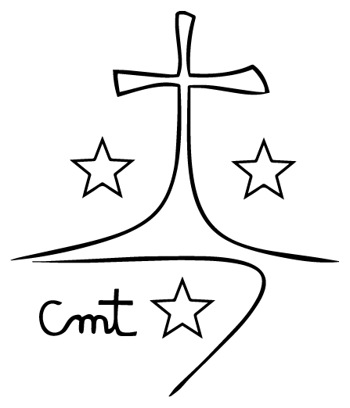

Animadora Provincial
CARMELITAS MISIONERAS TERESIANAS
Arturo Soria, 226
28033 Madrid
Tel: +34 636 53 78 99
provincial.europa@cmtpalau.org

Reg. nº 58/2026

CLOSING MESSAGE
OF THE IV ASSEMBLY OF THE “SAN LORENZO RUIZ” DELEGATION OF ASIA

«Let us always, always move forward,
until we become the likeness and image
of God, always forward.»
(EVV 3)

Sisters, during these days of assembly, in the light of the chosen theme, “Mystics of Today, Guardians of Life”, we have reflected on our lifestyle and mission as the Palautian family and unions of fraternity. As the fruit of this process, we have set down these options and objectives that will guide our processes as the Palautian family and as missionary communities.
I believe we have emphasized the need to return to the sources of the Gospel and of the charism in order to strengthen our identity and foster healthy relationships; to promote the living out of interculturality; to embrace a style of leadership marked by a synodal spirit; to give special care to vulnerable persons and to the world of young people; to strengthen formation at different levels in this process of transformation and growth; and to grow in our commitment to our common home and to the implementation of a sustainable and supportive economy.
I trust that the interiorization of these options and of the themes addressed, and their subsequent development into concrete actions, will sow seeds of hope and life in the various contexts in which we are present.
I want to thank Sister Gloria Esther once again for the service rendered over the past four years, and Sister Sharon Villafranca for her willingness to assume the service of animation and governance of the Delegation. Thanks also to Sister Eden Sales and Sister Clarynce Subijano for accepting to share this responsibility. The light of the Word and the strength of the Spirit will guide you in discernment to build up the common good.
Thank you sisters, all of you, for your active and responsible participation in this Assembly and for the joyful and family spirit in which it has taken place. To the sisters who prepared every detail, to the working teams, to the lay people for the richness of the shared experience, to the community that has welcomed us, and to the support team who have cared for us so attentively through their various services.
I entrust this new stage of the Delegation’s journey to Mary’s intercession. Let us walk with hope, aware that hope is incompatible with the culture of immediacy. The transformation we desire takes time. A seed does not become a tree overnight; it requires time and care.
To face this new stage with hope means becoming protagonists of our own history, transformative agents of a more humane and habitable reality. For this great mission, the light of the Word and of the charism will not be lacking, nor will the strength of the Spirit. Therefore, I conclude as I began, letting the words of Father Palau resound: «Let us always, always move forward, until we become the likeness and image of God—always forward».

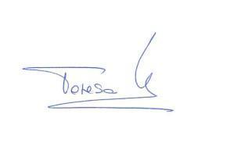
With these wishes, I declare the IV Assembly of the “San Lorenzo Ruiz” Delegation of Asia officially closed.
Manila, February 16, 2026




Teresa Vives Pertusa
Provincial Animator
Mª Carmen Moya Guerrero
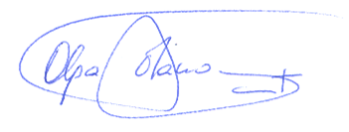
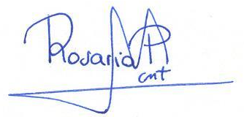
Provincial Secretary

