

CARMELITAS MISIONERAS TERESIANAS
Delegation of San Lorenzo Ruiz-Asia

February 15, 2026
The sisters attended the mass in the parish. The assembly started with an opening prayer by Sr. Aleksandra Nawrocka. Sr. Clarynse N. Subijano and Sr. Marissa M. Abuel presented the first draft of the options together with the Lay. Afterwards, they followed the process of reflection, sharing with the group, and later on, the approval of the four options in relation to the Lay.
The lay participants coming from the different communities shared their lived experience with the sisters: Ms. Julie Florita was grateful to be part of the assembly in contributing to the final plan of the options of the delegation. She is one of the members of MILPA-Pangantucan. The young couple, Silvester and Annabelle Sun, was also honored to be part of the history of the CMT family. Silvestre, moreover, was also very impressed with the experience, although he’s the only man in the group, he felt the inclusivity. Bibiana Reyes, the director of Sister Teresa Mira Center in Lucena, was also delighted and continued to be inspired for the second time around of her participation in the said assembly. She felt drained, but the family atmosphere and the consultative process helped them to come up with the crafting of the options of the lay with the sisters; moreover, she’s very thankful. They had the group pictures with the group.
Sr. Teresa Vives Pertusa, the Provincial Animator, read the appointment of the new Provincial Delegate:
- Sr. Sharon S. Villafranca – Provincial Delegate
Then, votation of the councilors that will form the Provincial Delegation Team. The two young sisters served as the Escritaduras:
- Sr. Eden P. Sales – First Councilor
- Sr. Clarynse N. Subijano – Second Councilor
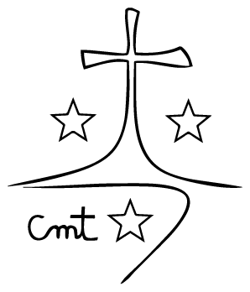
Later on, the sisters had personal reflection, proceeded to the discerning group for sharing of the options. They ended the day with a song of Mary.

